**CS 214 Database Technologies – SQL and NoSQL**

**PE09 - NoSQL Queries – elemMatch and comparison operators**

Center for Information Assurance (CIAE) @City University of Seattle (CityU)

7/6/2020 Developed by Clark Ngo



**Before You Start**

* If you have questions about the lab requirements, please ask a TA to clarify for you.
* If you are not sure what to do:
  1. Consult the resources listed below.
  2. If you cannot solve the problem after a few tries, ask a TA for help.

**Lab Tasks**

* Write NoSQL queries to complete the given tasks

Write a MongoDB query to find the restaurants who achieved a score more than 90.

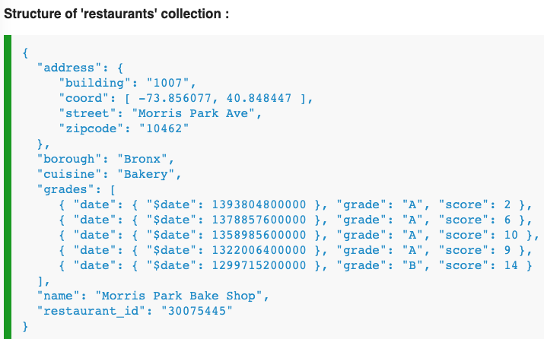

Research here: <https://docs.mongodb.com/manual/crud/>

<https://docs.mongodb.com/manual/reference/operator/query/elemMatch/>

Query:

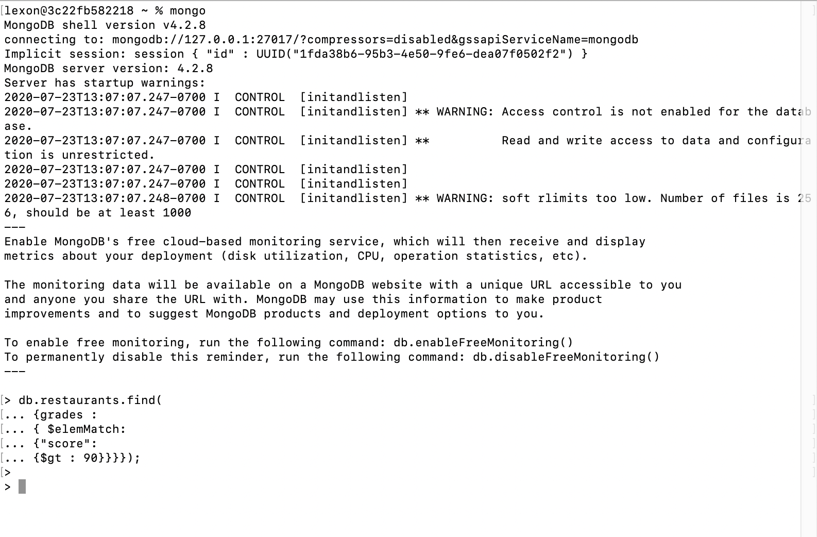

Write a MongoDB query to find the restaurants that achieved a score is more than 80 but less than 100.

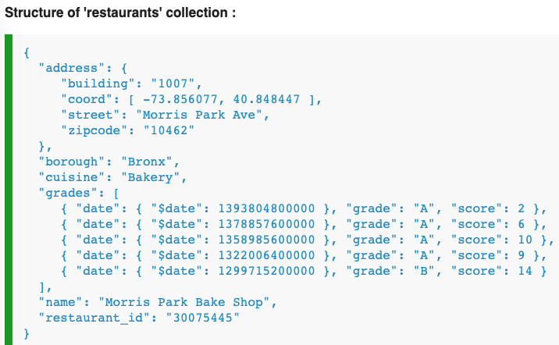

Research here: <https://docs.mongodb.com/manual/crud/>

Query:

